1. Find the IP address of the computer you are currently using.

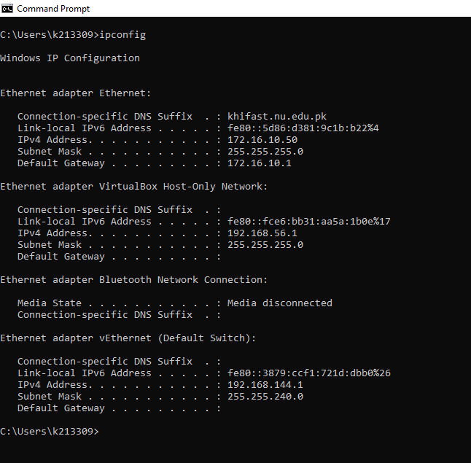

1. Find the IP address of the computer you are currently using, plus MAC address, plus whether DHCP is turned on.

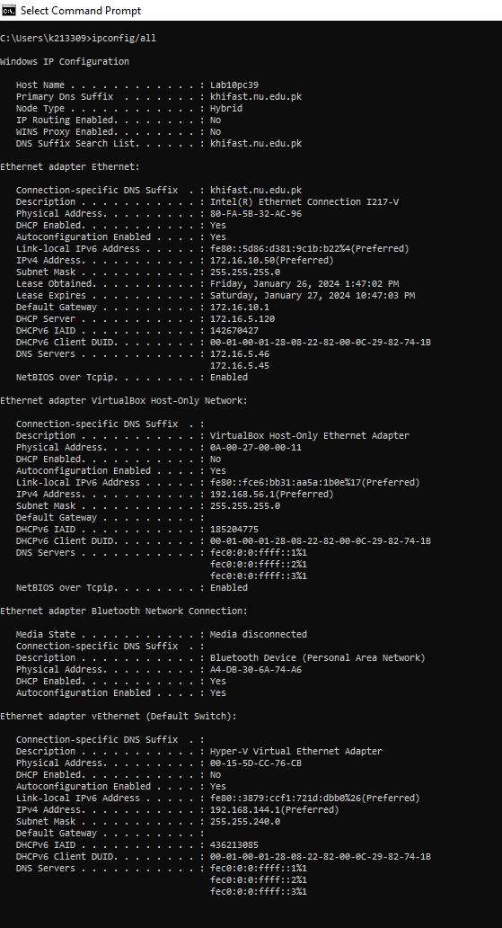

1. Display the host name of the computer.

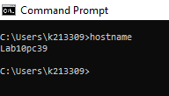

1. Check for basic IP connectivity between two computers by name and IP address. How can basic IP connectivity be checked? What are the reasons why there is no connectivity?

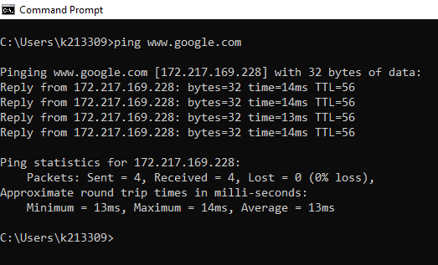

There is connectivity.

1. Show the MAC address of the host.

1. Show what shared resources are available on the host.

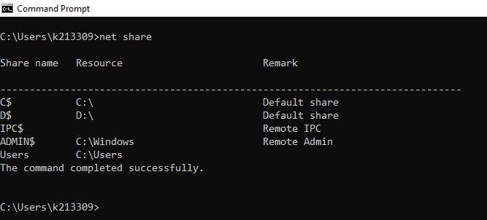

1. Find out which ports on your host are connected to applications. Connect the browser to some external web page before running the appropriate command.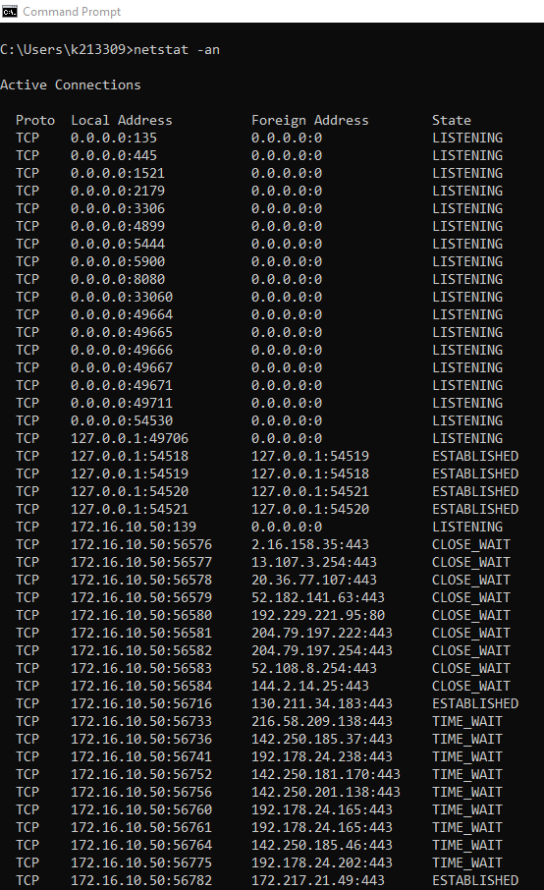

1. Find all other hosts available on the network.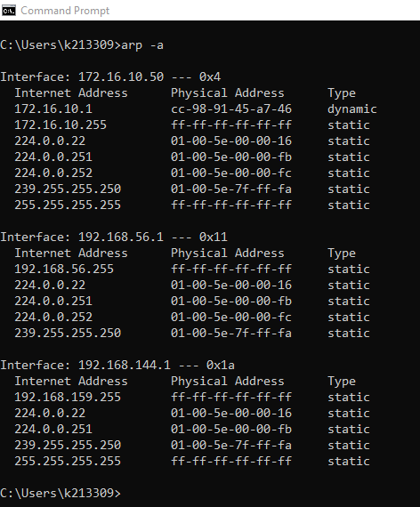

1. Show the address of the gateway.

1. Find the path of routers to www.google.com.What is its IP address? How many hops involved in the path?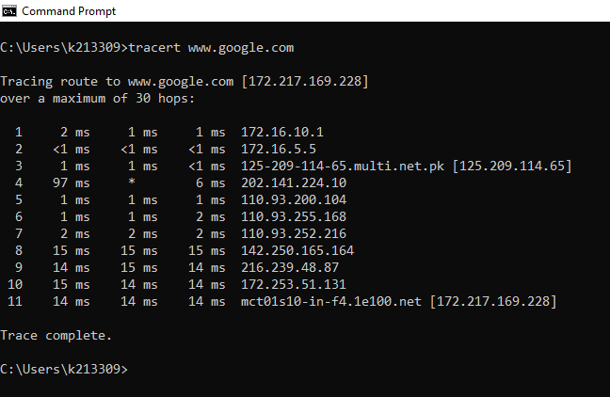

1. A ping to 192.168.0.2 works but a ping to the machine’s name “blue machine” fails. What could be wrong? 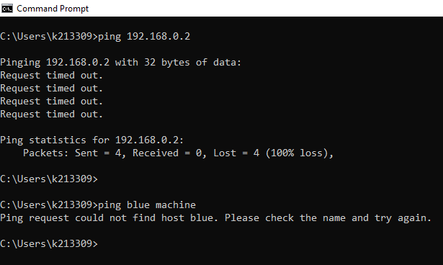

The device “Blue Machine” does not exist.

1. Which type of cable will you use to connect in a normal home installation? Give reasons.

Optical Fibers/ Ethernet. This is because it provides direct connectivity between a device and a network, and has high bandwidth and throughput.

1. Can you connect a Switch to another Switch or a router to a PC using a straight-through cable? Explain your answer.

Yes, you can. This is because they have RJ-45 connectors on each end o f a cable.

1. Write a brief report on your home network or any organizational network including topology, 1 page max).

My home network is StormFibre. Since we have a small number of devices, a router can handle all the network traffic from inside and outside the network. Therefore the router connects the LAN with the WAN.

1. Find the path of routers to www.yahoo.com.my. What is its IP address? How many hops involved in the path?